**ASSIGNMENT-8.5**

Parsing JSON files using pig

Convert the JSON data into CSV using pig and store the result in a file.

1. Loading the whole data using Jsonloader as separate columns:

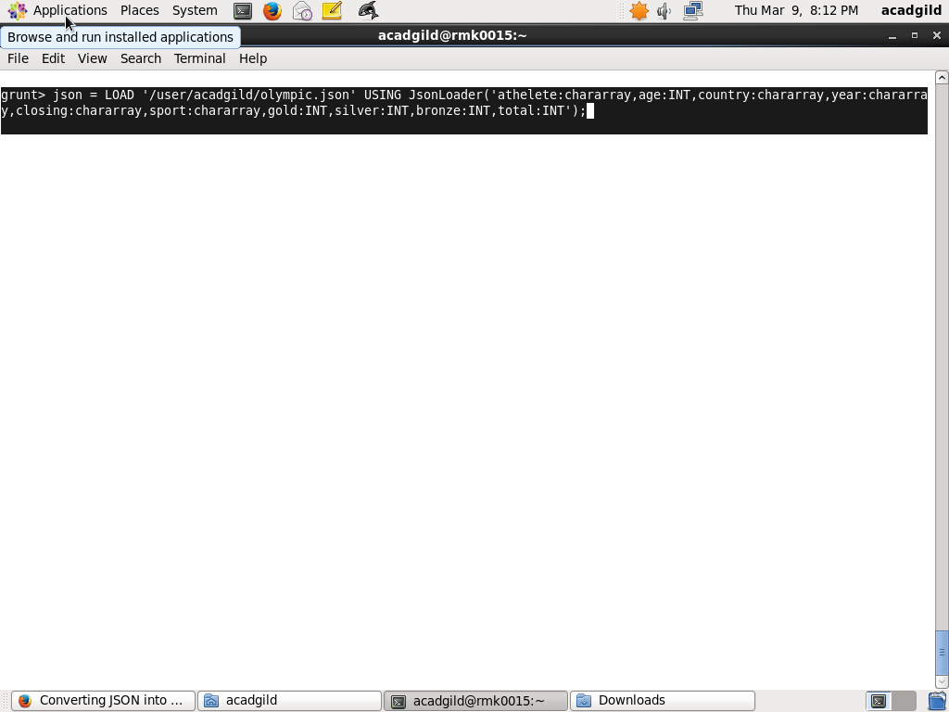

1. Store the date into a location as a CSV file using CSVExcelStorage():

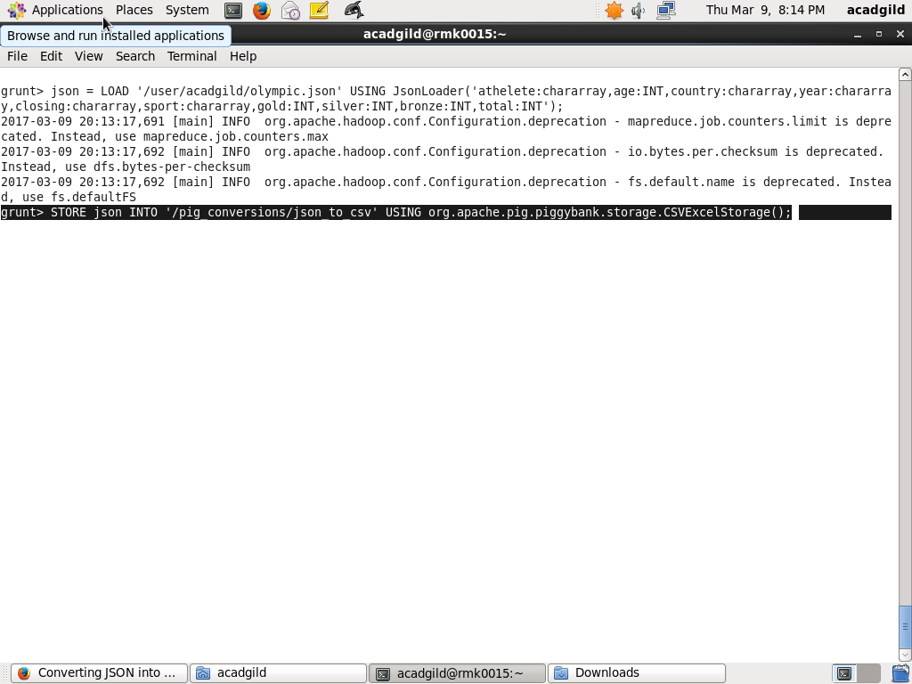

OUTPUT:

